**Data Mining & Machine Learning – Assignment 4**

(20% of total grade)

**\*\*\* Important Notice \*\*\***

Handwriting is allowed ONLY in pictures and formulas (NEVER in texts).

Texts should be typeset.

You will get a 15% deduction when not sticking to this rule.

***

* If two homework submissions are found to be similar to each other, both submissions will receive 0.

* Homework solutions must be submitted through Canvas. If you have multiple files, please include all files as one zip file.

* For coding assignments, it is strongly recommended to use **Jupytor notebook** and submit **.ipynb** file.

* Answers with **math expressions** and **graphs** can be handwritten and scanned.

* If you find any **typo/error** in the assignment, let me know.

1. [5 pts] (Refer to p. 54 in deep learning slide) Suppose we use MSE(mean squared error) error function in this RNN. Compute the error of first step (input=’h’)

2. [3 pts] In p. 55 in deep learning slide, suppose the output of RNN is not forwarded as an input to the next step. In this case, does the RNN always generates the same output in each step? Explain in detail “**USING”** the formula of RNN node.

3. [3 pts] In semi-supervised learning, we use both labeled and unlabeled data. During the training process we repeatedly predict (and also update) the label of unlabeled data and use them in supervised learning. In this case using cross entropy error function and using KL divergence have the same result? Explain it in detail “**USING”** the formula of cross-entropy and KL divergence.

4. [3 pts/ea] In sigmoid function, explain the following “**USING”** the graphs of activation functions.

1) When the initial weight values are very high, sigmoid may cause vanishing gradient. Explain it in detail

2) When all weight values are normalized around N(0,1), entire network may become a linear model. Explain in detail.

3) In gradient descent, using tanh usually makes it converge faster than using sigmoid. Explain the reason.

5. [3 pts/ea] Neural network with many hidden layers and each hidden node is using ReLU.

1) Explain why ReLU sometimes has the effect of Dropout.

2) Explain why output values may explode (grows exponentially)

3) ReLU function sometime has the effect of regularization (making the model compact) especially when many input values are negative. Explain this in detail using the formula of ReLU.

6. [3 pts] If we use batch gradient with a large dataset and error function is mean squared error (not sum squared error), we may have a vanishing gradient. Explain the reason **USING** the formula of batch update gradient.

7. [4 pts] In p. 23 in “gradient-descent” slide, explain the rightmost picture.

8. [4 pts] In p. 29 in “gradient-descent” slide, explain why the method uses ‘n_in’ parameter.

9. [4 pts] Explain why we can NOT use the gradient method in hyperparameter optimization. Explain this **USING** MSE error function with L2 regularization.

10. For the following confusion matrix

|  |  |  |
| --- | --- | --- |
|  | Pred Pos | Pred Neg |
| Actual Pos | 50 | 10 |
| Actual Neg | 5 | 100 |

1) [4 pts] compute precision, recall, specificity, f1-measure

2) [6 pts] draw a ROC graph using the following values.

True Labels: [1, 0, 1, 0]

Predicted Probabilities: [0.8, 0.3, 0.6]

11. [8 pts] Using the following table, verify whether algo 1 and algo 2 are statistically similar or different using paired t-test.

|  |  |  |
| --- | --- | --- |
| experiments | Algo 1 | Algo 2 |
| 1 | 70 | 75 |
| 2 | 65 | 68 |
| 3 | 80 | 82 |
| 4 | 90 | 94 |
| 5 | 60 | 66 |

12. [5 pts] In the following acquisition function in Bayesian optimization, explain why the X values near X=5.5 is the best choice for the next parameter value.

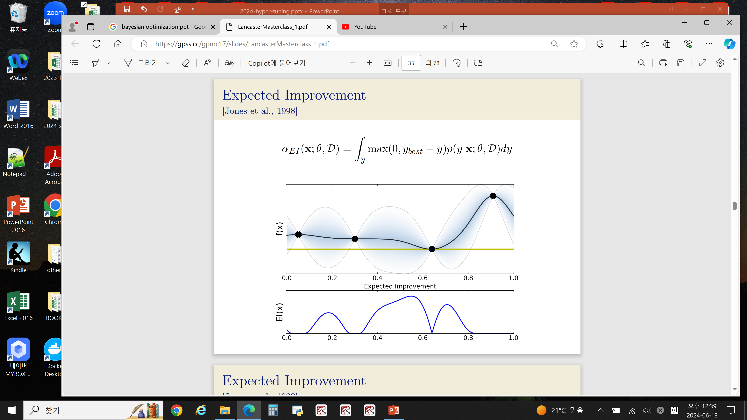

13. [5 pts] In Bayesian optimization, the functions generated in Gaussian process are smooth (e.g., the functions in p. 24) Explain the reason **USING** the following kernel function.

**\* For coding assignments:**

1) Don’t change the basic program code (unless you have my permission).

2) Never use any ready-made library to implement algorithms (except for bonus questions)

3) Don’t put entire program in one cell in Jupyter. Instead, for each sub questions, show the corresponding program code in .ipynb and explain it.

4) Don’t copy from other sources

5) HWs violating these guidelines will get zero.

14. (coding) **Transfer learning VGG16 + cifar 10**

You have to install Tensorflow library first. (Tensorflow includes keras)

1) Complete the following code

from keras import datasets, layers, models

from keras.utils import to_categorical

from keras.models import Sequential

from keras.layers import Dense, Flatten

import matplotlib.pyplot as plt

import numpy as np

(train_images, train_labels), (test_images, test_labels) = datasets.cifar10.load_data()

# Creating a list of all the class labels

class_names = ['airplane', 'automobile', 'bird', 'cat', 'deer', 'dog', 'frog', 'horse', 'ship', 'truck']

# Converting the pixels data to float type

train_images = train_images.astype('float32')

test_images = test_images.astype('float32')

# Normalize input

train_images = train_images / 255

test_images = test_images / 255

# change target class to one hot encoding

# use ‘to_categorical’ function

num_classes = 10

train_labels = OOO

test_labels = OOO

‘’’

14. 1)-1 (2 pts)

YOUR WORK HERE

Change above train_labels and test_labels to one hot encoding, respectively

‘’’

X_train=train_images

X_test=test_images

Y_train=train_labels

Y_test=test_labels

‘’’

14. 1)-2 (2 pts)

YOUR WORK HERE

1) Show the shape of (train_images, train_labels), (test_images, test_labels)

2) Show 1 sample image

‘’’

# Create network model using transfer learning

# fine_tune: # of layers to be trainable

def create_model(input_shape, fine_tune=0):

# Pretrained VGG16 networks are loaded.

# include_top is set to False, in order to exclude the model's fully-connected layers.

conv_base = VGG16(include_top=False,

weights='imagenet',

input_shape=input_shape)

# Defines how many layers trainable(updatable) during training.

# Layers in the convolutional base are set to non-trainable

# depending on the size of the fine-tuning parameter.

if fine_tune > 0:

for layer in conv_base.layers[:-fine_tune]:

layer.trainable = False

else:

for layer in conv_base.layers:

layer.trainable = False

# Create a few dense layers of the model (i.e. fully-connected layers).

# This is a new top_model onto the pretrained layers.

flatten_layer = Flatten()

‘’’

14. 1)-3 (4 pts)

YOUR WORK HERE

(How to define layers in Keras? Refer to https://keras.io/api/layers/)

1) Add 2 dense (fully-connected) layers: each with 20 and 10 nodes, respectively.

2) Add one output layer with 10 nodes)

‘’’

model = models.Sequential([

conv_base,

flatten_layer,

OOO (from 14.1)-3

OOO

OOO

])

return model

input_shape=X_train[0].shape

model=create_model(input_shape, fine_tune=0)

print(model.summary())

‘’’

14. 1)-4 (4 pts)

YOUR WORK HERE

train the model

1) use compile and fit

2) Show accuracy of test_images

‘’’

2) [4 pts] change the number of layers you want to freeze. Plot a graph accuracy vs number of trainable layers. What is the optimal number of layers?

3) [bonus 8 pts] Use mnist dataset as an input and repeat above process.

15. (coding) **Gradient descent (RMSProp)**

1) Implement the following RMSProp

import numpy as np

# Define the function and its gradients

def f(x, y):

return x**2 + 2*y +3*x

# Compute the derivative with respect to x

def f_der_x(x):

‘’’

15. 1)-1 (2 pts)

YOUR WORK HERE

return derivative value wrt x

‘’’

# Compute the derivative with respect to y

def f_der_y(y):

‘’’

15. 1)-2 (2 pts)

YOUR WORK HERE

return derivative value wrt y

‘’’

# Implement RMSProp

# RMSProp parameters

# : gamma

# : lrate

# : epsilon

gamma = 0.8

lrate = 0.01

epsilon = 1e-8

# Accumulated gradient squares for x and y, respectively

# : gt_x and gt_y

gt_x = 0

gt_y = 0

# Initial values of x and y

x, y = 10.0, -10.

no_iterations = 100

# RMSProp optimization loop

for i in range(no_iterations):

‘’’

15. 1)-3 (8 pts)

YOUR WORK HERE

For variable x, compute f_der_x ( ) and gt_x ( )

Repeat above for variable y.

Update variable x and y, respectively.

‘’’

# Show the progress

print(f"Iteration = {i + 1}: x = {x}, y = {y}, f(x, y) = {f(x, y)}")

‘’’

15. 1)-4 (2 pts)

YOUR WORK HERE

Show the final x value and f value.

‘’’

2) [bonus 4 pts] Add L2 regularization. You have to modify f, f_der_x, f-der_y functions.

3) [bonus 8 pts] Implement AdaDelta. You have to define the following and modify the update rule.

16. (coding) **Bayesian optimization**

Suppose you want to optimize a hyperparameter X(e.g., learning rate). We are going to achieve it using Bayesian optimization.

1) Implement the following program code.

import numpy as np

import matplotlib.pyplot as plt

# Define the true function

# Suppose the true error function is cosine function

def true_function(X):

return np.cos(X)

# Define the RBF (Radial Basis Function) kernel (Gaussian Kernel)

# Computes the RBF (Gaussian) kernel between two vectors X1 and X2.

# X1 : numpy array 1D (size=n)

# X2 : numpy array 1D (size=m)

# lambda() : Kernel coefficient for RBF

# returns:

# K : numpy array of shape (size of X1=n, size of X2=m).

def rbf_kernel(X1, X2, lambda=1.0):

‘’’

16. 1)-1 (6 pts)

YOUR WORK HERE

1) Implement the following RBF kernel K

where

2) return K

‘’’

# Define the Gaussian Process Regression function

def gaussian_regression(X_train, y_train, X_test, lambda=1.0):

‘’’

16. 1)-2 (16 pts)

YOUR WORK HERE

Perform Gaussian Process Regression

Given test data X_test, we compute and using the following formula.

: X_train

: y_train

: X_test

: mean of X_test

: Covariance of X_test

Suppose the size of vector and vector , respectively. The shapes of matrices in above formula are as follows.

You have to the following.

1) Calculate the inverse of covariance matrix of the training data

2) Calculate the covariance between training data and test data

3) Calculate the covariance matrix of the test points

4) Compute the mean of the posterior predictive distribution

5) Compute the covariance of the posterior predictive distribution

7) return and

‘’’

# Suppose you did the following 6 experiments changing the values of ‘X_train’.

# ‘y_train’ is its corresponding error function value

X_train = np.array([[1], [3], [5], [6], [7], [8]])

y_train = true_function(X_train).ravel()

# Let’s estimate the error function value when x=2.2

X_test=np.array([[2.2]])

‘’’

16. 1)-3 (6 pts)

YOUR WORK HERE

1) By using Gaussian_regression function, estimate mean and covariance of ‘X_test’

2) Compute standard deviation(s.d.) of X_test values (diagonal values of covariance is variance value)

‘’’

2) [4 pts] Now change X_test to X_test=np.array([[3.4]]). Compute mean and s.d. of X_test=3.4.

3) [6 pts] Now X_test=np.array([[2.2]]) is changed as follows.

X_test = np.linspace(0, 10, 10).reshape(-1, 1)

By using Gaussian regression, show the mean value vector and s.d. vector for X_test, respectively.

4) [4 pts] After Q. 3) is finished, at the end of the program, run the following and show the Gaussian distribution of error function.

# Plot the results

# mean: mean value vector of X_test

# sd: standard deviation vector X_test

plt.figure()

plt.plot(X_test, true_function(X_test), 'r:', label="True function")

plt.plot(X_train, y_train, 'r.', markersize=10, label="Training data")

plt.plot(X_test, mean, 'b-', label="Prediction")

plt.fill_between(X_test.ravel(), mean - 1.96*sd, mean + 1.96*sd, alpha=0.2, color='b', label="Confidence interval")

plt.xlabel('X')

plt.ylabel('y')

plt.title('Gaussian Process Regression')

plt.legend()

plt.show()

5) [6 pts] (Lower Confidence Bound) For each value in X_test of Q. 3), compute lower confidence bound value.

‘’’

YOUR WORK HERE

1) For each X_test value, compute the following UCB value.

: mean

: standard deviation

2) Choose your next hyperparameter value X based on above results

‘’’